
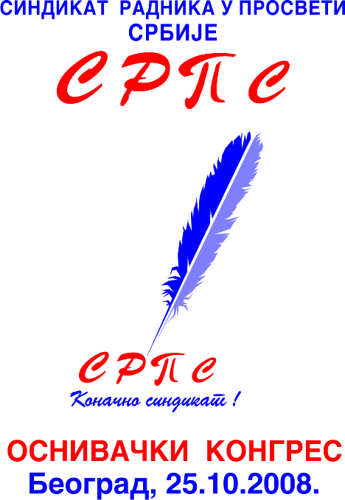
БЕОГРАД, Дечанска 14/5; соба 17-ф крило; тел/факс; 011/323-62-59, email; sob@beograd.com, sindiso@sbb.rs 025/42-00-93

No.23
Belgrade, 10/12/2009

ILO SRO Budapest Office
Mr. Jovan Protić, national coordinator in the Republic of Serbia

ICFTU
Mr. Guy Ryder, General Secretary
Ms. Sharan Burrow president

EI Education International
Fred van Leeuwen, General Secretary

To the Ambassador to Serbia

FES Belgrade

ICFTU Regional Office Sarajevo

To the news media:
VOA, Slobodna Evropa, Deutsche Welle, BBC

Subject: Information regarding the state of social dialogue in Serbia

To whom it may concern:
Across the world it is expected, if not implicit, for employers and/or state to obstruct the social dialogue, collective negotiation, and a right to union organizing. Unfortunately, the major problem for the union formation in Serbia is a union, in fact the very one that was supposed to be the core of the independent union movement in Serbia and further- UBS “Independence” (UGS “Nezavisnost”). Not having been satisfied with the union organization during the reign of Milosevic, a number of brave men made an attempt to preserve the rights of the working class that had been endangered, their working positions, and properties. The ultimate goal was a socially just and democratic Serbia. In that point in time, it appeared that UBS “Independence” was the solution. Unfortunately, that very syndicate transformed into its opposite and turned into a prisoner of a small group of people- its management, consisting of: Branislav Čanak, Zoran Stojiljković, and Slavko Luković. In the meantime, hundreds of extraordinarily devoted members abandoned the organization, either by their free will or after being forced to leave by their presence in the organization being made unbearable, and the only plausible choice left was to depart. That was the scheme by which UBS “Independence” lost people who formed ulterior unions – Association of Free and Independent Trade Unions (ASNS), Confederation of Free Unions of Serbia (Konfederacija slobodnih sindikata Srbije), and recently United Labour Unions of Serbia (Udruženi radnički sindikati Srbije,URSS).
With the same strength once used for finding its place under the sun, UBS “Independence” now prevents other syndicates from organizing, registering and participating in the social dialogue, and by a simple strategy. By imposing the standards present in the countries with high level of industrial democracy, unions in Serbia have produced the Constitution which enabled social dialogue and the participation of the representative unions in social dialogue and tripartite entities (state-employers- syndicates). Based on the criteria given in the Labour Law, unions and the employers’ associations were under the obligation to affirm the right of representation of these organizations, which they did in 2005. The threshold for achieving representativeness at that point was 10% of the total number of employed workers on the national level. That number was achieved by Confederation of Autonomous Trade Unions of Serbia (SSSS), and purportedly UBS “Independence” on the behalf of unions and the Serbian Association of Employers (Unija poslodavaca Srbije) on the behalf of the employers’ organizations. Following the alleged affirmed representativeness, Slobodan Lalović, at that time holding a position of the Minister of Labour, issued a credential of representativeness to these organizations. The Labour Law restricted the representativeness to the time period of three years, and left the possibility for employers/ organizations and unions to dispute the representativeness of the organizations that were deemed representative after the expiration of those three years. In the meantime, organized syndicates utilized the opportunity and filed a claim with the Ministry of Labour for reappraising UBS “Independence”‘s representativeness. Association of Small and Medium Enterprises (Asocijacija malih i srednjih preduzeća) acted along the similar lines and questioned the representativeness of the Serbian Association of Employers. It is necessary to point out that in the meantime, a number of branched syndicates also received representativeness. As an example we present the syndicates in the area of education: Serbian Syndicate of Education (SOS, Sindikat obrazovanja Srbije), and the Branched Syndicate of Education Workers of Serbia “Independence” (GSPRS “Nezavisnost”), which became representative in September, 2005, and the Union of Education Workers’ Syndicates of Serbia (USPRS) in January, 2006. In the meantime, immense boards from the territory of the City of Belgrade and the Autonomous Province of Vojvodina separated from these syndicates to form a new syndicate- Union of Education Workers of Serbia (Sindikat radnika u prosveti Srbije- SRPS). They further submitted a claim for enrolment in the Register of Union Organizations handled by the Ministry of Labour and Social Policy. Simultaneously, Union of Education Workers of Serbia, as an organization structured on a national level, filed a claim for representativeness to be revoked from Serbian Syndicate of Education (SOS) and BSEWS “Independence” (GSPRS “Nezavisnost”) due to its expiration in September, 2008., as well as from the Union of Educational Workers’ Syndicates of Serbia (USPRS) due to its expiration in January, 2009. Nevertheless, for over a year now, there is a blockade preventing new unions and union centrals from being registered, due to the fact that an auxiliary body to the Minister of Labour, Mr. Ljajić, the Board for Establishing the Representativeness of Trade Unions and Employers, is not evaluating filed claims for representativeness. Even though there is a 15 day judicial deadline, this Board has resolved a single claim positively since being formed (the one regarding the Independent Police Union (NSP)) and a single claim negatively (the one regarding the Independent Union of Employees in Public Services of the City of Belgrade (Nezavisni sindikat zaposlenih u komunalnim delatnostima Grada Beograda)). At the same time, nearly 40 unions are left to wait between 7 months and a year and a half for their claim to be considered and resolved. The obstruction of work is being carried out quite inventively and efficiently, and after all the means have been depleted, due to the fact that Board’s decisions are being made by a consensus, representative of the UBS “Independence” hampers every decision in the Board. Bearing all of the given facts in mind, our union held a protest in front of the Ministry of Labour, made written statements to everyone with authority on the matter in the Republic of Serbia, starting with the Minister of Labour, going all the way to the Prime Minister and the President himself. Unfortunately, all of the efforts proved to be ineffective.
Minister of Labour uncritically took the side of USB “Independence”, even though all of the participants in the Serbian social dialogue are entirely aware that this organization lost the legitimacy and legality to represent the workers in Serbia. Minister provided a rationale that he was in need of two syndicates, but that was only to create an illusion of social dialogue and union pluralism, and is in fact a fallacy and disarray introduced by the Minister into the field of Labour. That is the manner by which the Minister becomes an accomplice to a syndicate that, even though it was representative, no longer is. Thus, Mr. Branislav Čanak’s status in the Administrative Board of the ILO as a representative of all trade unions in Serbia is to be questioned, as well as the position of his colleague Mr. Branislav Pavlović, the president of Union of Education of Serbia (TUS), as a delegate of all education syndicates in Serbia in Pan-European Committee, and a member of the National Board of Education (Nacionalni prosvetni savet). At the same time, as a member of the aforementioned Board for establishing the representativeness, Mr. Pavlović did everything in his power to prevent representativeness from being awarded to the Independent Union of Education Workers in Vojvodina (Nezavisni sindikat prosvetnih radnika Vojvodine) and the Union of Education of Belgrade (Sindikat obrazovanja Beograda, SOB).
Mr. Pavlović followed the example of his colleague Mr. Čanak, and instead of contributing to the development of the union scene in Serbia, they use their representative positions in international organizations so as to prevent the workers in Serbia from exercising their right to form organizations and unions.
We would like to observe that forty and more unions currently waiting for their representativeness to be affirmed and therefore be enabled to participate in collective negotiations and social dialogues, have thousands of hundreds of members who are impaired as they cannot practice their right to protect their legal-working and materially-social status. Representatives of the Ministry of Labour and Social Policy have provided explanations for the delays in processing the syndicates’ claims for their representative status to be confirmed by proclaiming the Labour Law and Internal Rules of the Board in charge as encumbrance and the cause of inefficiency. We do not find this justification valid knowing that the Minister has the legal authority to declare certain clauses of the Internal Rules inoperative if they conflict with the statute and by doing so he has the power to unblock the Board’s functioning.
We consign this notice, not only on behalf of the Union of Education Workers of Serbia (SRPS), but also on the behalf of approximately 40 union organizations that filed a claim for their right of representation to be affirmed.
We plead that you, according to the authority your organization posses, put pressure on the bodies of Government of the Republic of Serbia, so that they would enable activity and acting of the union organization consistent with ratified international conventions and the Constitution of the Republic of Serbia.
We are immensely grateful for your time and effort.
In expectance of your appreciation for our procurement, we are a forehand thankful.
Respectfully,

General Secretary President

Professor Hadži Zdravko M. Kovač Brajković Slobodan

